## UJIAN TENGAH SEMESTER (UTS) GASAL TAHUN AKADEMIK 2021/2022

|  |  |  |  |
| --- | --- | --- | --- |
| Mata Kuliah Fakultas/Prodi  Semester/Kelas | : Bahasa Inggris  : Teknik/Teknik informatika S1  : 04TPLP016 | Hari/Tanggal Waktu  Shift/Modul | : -  : 90 Menit  : Reguler A |
| Dosen | : Hidayatul Mu’arifin, SE.,Ak., M.M.. | Jenis Soal | : Utama |
| Sifat Ujian | : *Tutup Buku* | Ruang | : - |

Petunjuk mengerjakan soal :

1. Berdo’alah terlebih dahulu sebelum membaca dan mengerjakan soal.
2. Bacalah dengan seksama soal, dahulukan soal yang anda anggap paling mudah.
3. Jawablah soal dengan jelas, singkat dan benar sesuai dengan perintah soal.

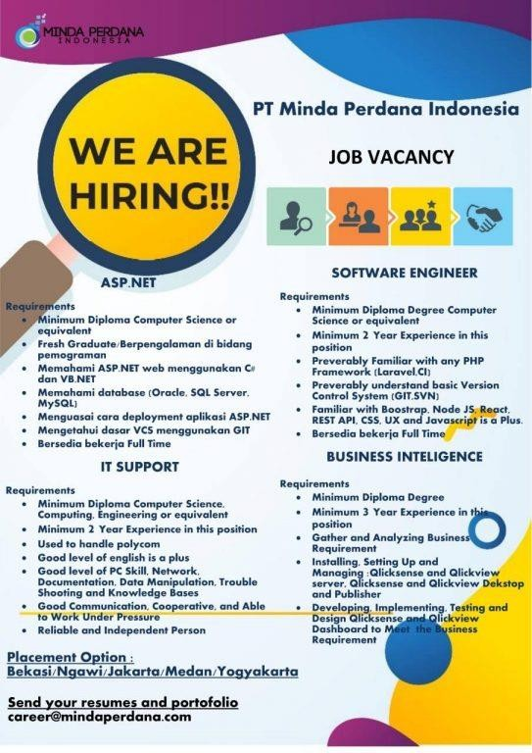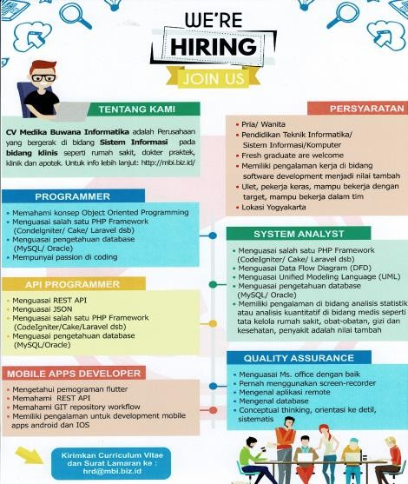

* 1. Please Make A Job Application Letter And List Of Living History According To The Job Vacancy Above And Choose One Of The Vacancy You Are Interested In
  2. Answer The Following Interview Questions
     1. Can you tell me about yourself?
     2. What do you know about this company?
     3. Why do you want to join this company?
     4. Why should we hire you?
     5. What are your weakness?
     6. How do you handle stress?
     7. What are your salary expectations?
  3. Please Make A Speech About Some Of These Themes And Choose One.
     1. The Importance Of Education In Today's Millennial Generation
     2. Student Views On Corruption
     3. Unemployment Due To Covid 19
  4. Please make at least 20 conversations with the following situations and choose one (Party, Supermarket, In class, Dinner)
  5. Please Watch The Video At The Following Link And Draw Conclusions From The Video And What Are Your Views And What Points Are Taken From The Speech

Link : <https://www.youtube.com/watch?v=2hOp408Ib5w>

**SELAMAT MENGERJAKAN** ☺

# LEMBAR JAWABAN

## NAMA : Andri Firman Saputra

**NIM : 201011402125**

1. **Job Application**

Andri Firman Saputra | Quality Assurance

Jl. AMD Babakan Pocis No. 88

Bakti Jaya, Setu, Tangerang Selatan

No. Telp: 087808675313

Tangerang Selatan, 18 April 2022

**Ms. Mary Jane**

HRD

Jiwasraya Company

Jl. Ir. H. Juanda No.34, RW.2, Kb. Klp.,

Kecamatan Gambir, Kota Jakarta Pusat, Daerah Khusus Ibukota Jakarta 10120

Dear Mary,

My name is Andri Firman Saputra hereby I would like to apply for a Quality Assurance position at your place of business. I applied for this position because it fits my background and I like new things. I have completed a bachelor's degree in computer science at Pamulang University and from that experience I am confident that I can master it as Quality Assurance.

I can assure you that I am a reliable and hard-working person. Therefore, I believe that I will be a good asset to your company. I look forward to joining your team to build my career and at the same time, working with your team to develop your company growth.

Your Sincerely,



Andri Firman Saputra

# LEMBAR JAWABAN

**Curriculum Vitae**

Name : Andri Firman Saputra

Date of Birth : 29th January, 2002

Place of Birth : Jakarta

Gender : Male

Religion : Islam

Citizenship : Indonesian

Status : Single

Residence Address : Jl. Amd Babakan Pocis No. 88 Rt04/02, Bakti Jaya,

Setu, Tangerang Selatan, Banten

Zip Code : 15315

Phone Number : 0878 0867 5313

Email : andrifirmansaputra1@gmail.com

Experienced in Microsoft Office and Database with 3+ years of experience creating documents for companies. Also, investigating new technologies to ensure that Jiwasraya remains a leader in setting industry standards.

**Education & Qualification**

2020 **University of Pamulang**, Jl. Puspitek, Buaran, Kec. Pamulang, Kota Tangerang Selatan, Banten 15310

**Core Skills**

* Microsoft Office
* Remote Application
* Knowing Database Mysql, SqLite
* Language: Indonesia (Active), English (Passive), Japanese (Passive)

**Experience**

2017-2017 **BPPT-B2TKE**, JMR8+FJG, Pabuaran, Kec. Gn. Sindur, Kabupaten Bogor, Jawa Barat 16340, work as IT Support and Developer Archive Software

# LEMBAR JAWABAN

1. **Interview Questions**
2. Can you tell me about yourself?

Experienced in Microsoft Office and Database with 3+ years of experience creating documents for companies. Also, investigating new technologies to ensure that Jiwasraya remains a leader in setting industry standards.

1. What do you know about this company?

Jiwasraya is the oldest life insurance company in Indonesia which is the forerunner of the Dutch-owned life insurance company NILLMIJ van 1859, which was finally nationalized and became state-owned in 1960.

1. Why do you want to join this company?

Since I'm interested in insurance, I want to know more about it, from how insurance works to insurance rules.

1. Why should we hire you?

I am looking for a job where I can grow with the company. Because apart from wanting to grow, I also want to be a valuable asset for the company.

1. What is your weakness?

I am sometimes slow in completing my tasks, because I really want to get them done right. I will check until it is correct.

1. How do you handle stress?

I will take a short break while drinking a cup of coffee and keep thinking positive.

1. What are your salary expectations?

I expect a salary commensurate with the work I do like out there.

# LEMBAR JAWABAN

1. **Speech About Unemployment Due To Covid 19**

**Togetherness in Economic Recovery**

Distinguished guests,

Today, more than a year we have been through a time full of uncertainty and challenges, due to the COVID-19 pandemic. In the document "Platform for Shaping the Future of the New Economy and Society" published by the World Economic Forum, by the turn of the year 2020/2021 it was noted that confirmed cases of COVID-19 had exceeded 77 million, with more than 1.67 deaths related to COVID-19. These figures illustrate the significance of the world health crisis posed by the pandemic.

In addition to the health crisis, the COVID-19 pandemic has also caused a world economic crisis. Social restriction measures taken by various countries to control the spread of COVID-19 have caused economic contraction in various countries. The economic contraction began with a decline in market demand as a result of restrictions on various social activities. Many companies, both large, medium and small, have experienced over-supply, and this has resulted in financial difficulties. As a further consequence, many workers lost their jobs, so that unemployment and poverty rates also increased. In turn, this has all led to various social impacts.

Currently we in Indonesia, as well as the entire world community, are entering the vaccination phase. By the end of 2020, a number of COVID-19 vaccines had obtained approval for production, and in early 2021 they had begun to be distributed. However, the supply of vaccines is still very limited, so that the distribution of vaccines cannot be comprehensive and even. This inequality does not only occur within a country, but also across countries. The limited supply and inequality of this vaccine will certainly bring consequences in the process of economic recovery. However, we all hope that with this vaccination, we can gradually control the spread of COVID-19 to a minimal level.

In a video message delivered at The Global Vaccine Summit, UN Secretary General António Guterres emphasized, "We need global solidarity to ensure that every person, everywhere, has access". Guterres emphasized that when a COVID-19 vaccine became available, “…it reaches everyone.” The UN Secretary General's message underlined a key word related to the post-pandemic period, namely: solidarity.

Distinguished guests,

Please allow me to take this valuable opportunity to convey things that are expected to be our common challenges in the post-pandemic period.

With vaccinations, people's immunity will gradually increase, and the health crisis will decrease, or end. This will lead to confidence in us to restart activities that involve face-to-face interaction. Social mobility will gradually increase. And all of this will lead to demand for various goods and services. The re-growth of market demand is a key factor for economic recovery. However, the re-growth of demand will not necessarily lead to a rapid economic recovery.

Various companies that are experiencing financial difficulties as a result of the pandemic, need time to be able to recover their business activities. The speed of business recovery will vary from one company to another, from one economic sector to another. This is also influenced by the speed and evenness of the vaccination process. This means that in the future we will live a period of economic recovery accompanied by uncertainties and challenges.

If you refer to the documents published earlier by the World Economic Forum, there are several notes regarding the period of economic recovery. First, as a result of the damage that occurred during the pandemic, it is not certain that all economic sectors will be able to be fully recovered, and return to the way they were in the pre-pandemic period. Second, our experience of going through a pandemic has become a source ofnew inspiration, which in turn will lead to demand for new goods/services. Third, in the pre-pandemic period, not all conditions were ideal. There are many economic, social and environmental problems that existed in the pre-pandemic period, which will remain a problem in the post-pandemic period. In other words, the process of economic recovery will be accompanied by the emergence of hopes for new conditions, or improvements to conditions in the pre-pandemic period.

For example, in the past we had limited experience with digital learning and remote working. During the pandemic, we are doing digital learning and remote working very intensively, with all its advantages and disadvantages. Although in the post-pandemic period most of the activities will return to face-to-face or off-line interaction patterns, there is the possibility of new exploration in the use of digital technology. This pandemic period provides inspiration to explore opportunities for using digital technology more inclusively, and pay more attention to the resilience aspect.

This pandemic period has also shown that the MSME sector, especially small and micro businesses, is not sufficiently resilient, and is not sufficiently capable of creating added value. This will be a trigger for us to pay more attention to increasing the resilience and innovation ability of MSMEs. Global trade conditions in the pre-pandemic period, limited our opportunities to develop domestic products. Such conditions are expected to change in the direction of trade deglobalization. These changing conditions open up opportunities for us to encourage domestic production, both for the needs of the domestic and export markets, through bilateral/multilateral trade cooperation. All of these things open up new opportunities, and at the same time pose challenges for us in the period of national economic recovery.

# LEMBAR JAWABAN

1. **Conversation at Supermarket**

Supermarket

Andri : Hi, are you Fiki?

Fiki : Hi, right

Andri : Long time no see you

Fiki : Long time no see you too

Andri : How are you?

Fiki : Okay and you?

Andri : Safe and healthy

Fiki : What brings you here?

Andri : I'm looking for food for sahur and a bottle of milk, then you?

Fiki : Oh, when I buy daily necessities like perfume, shampoo, soap, etc

Andri : By the way, where do you work?

FIki : I'm working on IT supporting at Sanken, how about you?

Andri : Good, I work as a game developer at Megaxus

Fiki : Is it cool to be a game programmer?

Andri : That's right, there are a lot of good and cool seniors making cool games too

Fiki : Cool dude, have you finished looking for things?

Andri : Yes, wait a minute? I want to buy facial soap first

Fiki : Okay I'm going to the cashier first

Andri : Hi Fik, you bought a lot

Fiki : Yes, it's for a month

Cashier : Total is 250,000-rupiah, sir

Fiki : Alright, wait a sec? I left my wallet in the car, may I borrow your money, Dri?

Andri : Relax, excuse me sir can i use a card

Cashier : Of course, sir

Fiki : Thanks, Dri, I'll change it later

Andri : Alright, do not forget please

# LEMBAR JAWABAN

1. **Draw Conclusions**

I can draw conclusions from Barack Obama's video speech entitled The Importance of Education, he teaches how important education is, how to solve unimaginable problems, not to learn material in school that will be useful or not someday, but how do we solve these problems. In addition, he taught how important it is to follow the existing rules and understand what those rules are.